Assignment 8
(Exercise on order by and group by clauses) Create Sales table with the following fields ( Sales No, Salesname, Branch, Salesamount, DOB)
( a ) Insert five records
Query:
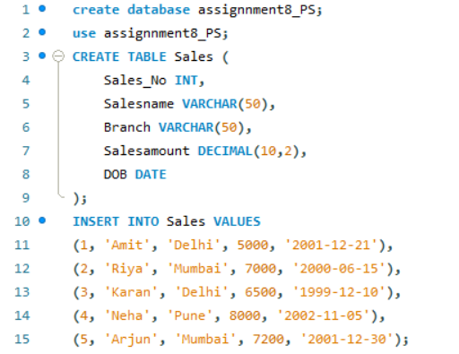

( b ) Calculate total salesamount in each branch
( c ) Calculate average salesamount in each branch ( d ) Display all the salesmen, DOB who are born in the month of December as day in character format i.e. 21-Dec-09
( d ) Display the name and DOB of salesman in alphabetical order of the month.
Query:
